Police and Crime Commissioner for Surrey – Decision Making Record

Report Title: Year-end Financial Performance and Budget Virements
Decision number: 015/2023
Author and Job Role: Kelvin Menon – Treasurer
Protective Marking: OFFICIAL

Executive Summary:

The Financial Monitoring report for the 2022/23 year end shows an underspend of £1.1m after taking account of the £7.5m of reserve transfers made earlier in the year. This is based on an approved budget of £279.1m for the year. Capital was £6.7m underspent due to the timing of various projects.
Financial Regulations state that all budget virements over £0.5m and asset writeoffs must be approved by the PCC. These are included within this decision notice.
Background

Revenue Outturn

The total budget for Surrey is £279.1m for 2022/23, against this the forecast outturn position is £276.7m resulting in an underspend of £2.4m.
 | 2022/23 PCC Budget £m | 2022/23 Operational Budget  £m | 2022/23  Total Budget  £m | 2022/23 Projected Outturn  £m | 2022/23  Projected Variance £m
Month 12 | 3.2 | 275.9 | 279.1 | 278.0 | (1.1)

More detail is given in the table below:
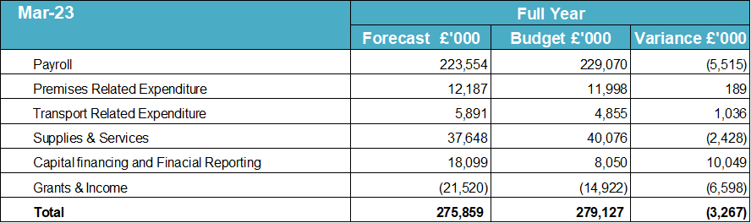
The largest element of the underspend is to do with staffing costs. A fixed number of officers (2,217) was budgeted for the entire year however in reality this number was not reached with numbers averaging 2,136 over the year. due to be reached until January thereby resulting in an underspend. For Police staff there were 229 vacnacies on average leading to a vacancy rate of almost 12 % - well above the 8% budgeted for. Some of these staff and officer vacancies were covered by additional overtime reulsting in a £2m overspend against a budget of £6.8m
Workshop and fuel costs resulted in a £1m overspend by the end of the year. The £10m shown as capital financing is in the main transfers to reserve at the end of the year. Grants and income have come in £6m over budget due to additional income from SEROCU, national events and grants awarded in year to the OPCC
Capital Forecast
The capital plan is forecast to underspend by £6.7m. Most of this is due to underspend in IT projects (£3m) and the estates (£1m). Some of these will be carried froward at the year end in to the capital program for 2023/24.

Revenue Virements
Per financial regulations only virements over £500k need approval from the PCC. These are set out below for quarter 4.
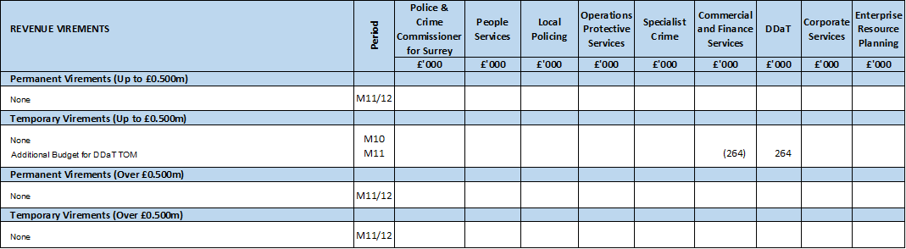
Reserve Transfers
The PCC is requested to transfer the underspend as follows to reserves

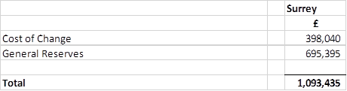
JTS Stock Write Off
The objectives of Project Veritas (Vehicle Telemetry) are improved safety, improved vehicle, fleet and CCTV data, reduced emissions, fleet optimisation and to provide accurate data for vehicle deployment. Reliable and accurate Telemetry data is necessary for insurance purposes as well as promoting good practice within the force and an enabler for Project Thrifty.

The current Telemetry solution was purchased outright but this has had a number of not system failures and reporting issues. It was also reliant on 3g technology which was being phased out. As a result a rental-based model is now being adopted that can keep pace with with the dynamic digital UK infrastructure. This means that some of the old equipment has now become obsolete and, after investigating whether can be sold, has meant that it will have to be written off in the 2022/23 accounts. For Surrey this amounts to £108,998

The Financial Regulations state that amounts written off in excess of £20,000 will be reported to the PCC and recorded as a key decision. It is therefore recommended that the PCC authorises the write off

Police and Crime Commissioner Approval

I note the financial performance as at the 31st of March 2023 and approve the virements and reserve transfers as set out above in the report.

I also approve the write off of stock of £239,872 as set out in this report

Signature: PCC Lisa Townsend (wet signed copy held in OPCC)

Date: 2nd August 2023

All decisions must be added to the decision register.

Areas of consideration

Consultation

None

Financial implications

These are set out in the paper

Legal

None

Risks

The third quarter of the year has continued to be very challenging in terms of staff recruitment. Whilst this has resulted in an underspend there are gaps in a number of areas leading to increased pressure on remaining staff and impacts risk to performance. This is being kept under review so that risks can be managed.

Equality and diversity
.
None

Risks to human rights

None

