To: Joint Audit Committee

Date: 25th June 2024

By: Chair of the Committee

Title: Audit Committee Annual Report
______________________________________________________________

Purpose of Report/Issue:

Provide assurance to the PCC and chief constable that the audit committee fulfils its purpose supporting the PCC’s accountability to wider stakeholders, including the public.
______________________________________________________________

Recommendation(s) -
1) Confirm agreement with the report or otherwise
2) Consider future actions suggested
______________________________________________________________

Equalities / Human Rights Implications – None arising.

Risk - As discussed in the report.

Background papers –

CIPFA 2022 edition Audit Committees: practical guidance for local authorities and police

CIPFA 2018 edition Position Statement: Audit Committees in Local Authorities and Police
______________________________________________________________

Contact details – c/o Sarah Gordon OPCC Office
Name: Patrick Molineux
Job Title: Chair JAC

______________________________________________________________

Summary
The format of this report which covers calendar year 2023 has been changed to follow the 2022 CIPFA Audit Committee guidance. It:
- Briefly outlines the extent to which the Surrey Police audit committee followed the CIPFA position statement in a number of defined areas.
- Summarises the result of the committee’s annual evaluation of its effectiveness and assurance over key indicators during 2023 disclosing where the committee had concerns and how it dealt with them.
- Summarises how the committee has fulfilled its terms of reference during 2023 and what key issues were escalated to the leadership team.
- Summarises any development work undertaken by committee members to enhance their effectiveness.
The purpose of the report is to provide assurance to the PCC and chief constable that their audit committee believes that it is fulfilling its responsibilities to them.

Alignment to CIPFA Position Statement
With regard to the seven points in CIPFA’s Position Statement:
- The committee believes that the OPCC and force treat the committee as a key component of the governance framework evidenced by the diligence with which the OPCC and force address recommendations and actions from the committee.
- The committee has assisted in the evolution with the risk management framework, and through its meetings assures the internal control environment and integrity of financial reporting. The committee provides oversight of both internal and external audit advising the PCC and chief constable of its independent perspective on both functions.
- The committee has adopted a model in line with CIPFA guidance. It is independent of the PCC and chief constable evidenced in its willingness to question decisions where it feels appropriate. The PCC and chief constable have provided all access to other governance that the committee has requested. The committee is directly accountable to the PCC and chief constable both of whom, or their deputies, are represented at audit committee meetings.
- The committee believes that it delivers against all core functions of an audit committee examining within its meetings and through work between meetings the risk management arrangements, internal audit, control environment, external audit, other inspection bodies, and financial statements.
- The committee, with the agreement of the OPCC and force, extended its remit in its terms of reference from the base CIPFA definition to cover oversight of a number of areas (such as EDI) and was pleased by how willingly the force and OPCC accepted the value the committee could add.
- The audit committee believes that its membership are independent both of the force and politically, and believes that across its members it brings a balance of experience of accountancy and audit, governance and general management, as well as offering a private and commercial sector perspective on matters relating to the Police which committee discussions suggest is valued by the force.
- The committee meets four times a year in line with CIPFA guidance, and meets privately with the external auditor, and internal audit before each meeting. Regular attendees at meetings, again in line with CIPFA guidance include the CFO, chief executive of the OPCC, head of internal audit, and external audit. The committee has on occasion called on other attendees. The committee avoids engaging in operational matters which are the domain of the chief constable, although it values the operational briefings during committees from the chief or his deputy which provide helpful background to the committee in understanding particularly the risk management arrangements.

Evaluation of Committee’s Effectiveness and Assurance
The committee has assessed itself against CIPFA’s Self-assessment of good practice which asks 40 good practice questions. The committee’s assessment is included in appendix 1. The committee has assessed itself for 2023 as 188 out of 200 with no areas of major, significant or moderate improvement required and six areas which required minor improvement in 2022 of which some have been addressed.
The six questions where minor improvement is required are as follows:
- From question 7, the governing body (the force and OPCC need to hold the audit committee to account for its performance annually). The committee believes this could be improved by the OPCC and a senior force leader reviewing and agreeing annually the committee’s “self assessment of good practice” (see appendix 1) and raising any improvements to the chair.
- The three sub-questions in question 8 relate to whether the audit committee publishes an annual report that complies with the CIPFA position statement 2022. The committee does publish an annual report but having reviewed its previous annual reports recognised that the format could be changed to better align to the CIPFA statement. This report seeks to follow the CIPFA statement exactly and the committee believes that these three questions will be addressed for the next annual report.
- Question 9 recommends that the terms of reference need to explicitly address internal control arrangements for financial management, value for money, ethics and standards and counter fraud and corruption. The committee believes that the terms of reference needed to be more explicit about internal control arrangements. These changes to the terms of reference have now been made during 2023.
- Question 15 recommends that within the last two years an evaluation of the knowledge, skills and training of the chair and members has been undertaken. The committee suggests that when the OPCC recruits replacement members in 2024, that they review the three remaining members for knowledge, skills and training alongside that recruitment as the knowledge and skills of the existing members will help inform the correct mix of new members.

Fulfilment of Terms of Reference
In line with CIPFA guidance, this report states how the committee has fulfilled its terms of reference by summarising the major topics and issues which the committee discussed and where necessary brought to the attention of the PCC and chief constable.
2023 – Quarter 1
The committee reviewed the external audit for the year ended 31 March 2022 finding no substantive issues. The committee challenged the external auditor on fees. Exploring further the relevant internal audit report, the committee paid particular attention to the management of IR35 off-payroll regulations and the risks faced by the force escalating the need for the OPCC and force to ensure effective compliance arrangements were in place.
The committee noted and discussed a substantially updated report that it had requested on outstanding actions from external inspection bodies probing whether the force was addressing these actions in a sufficiently timely manner. The committee noted the progress on closure of HMICFRS actions.
The committee noted the very substantial improvements made in the risk management arrangements where huge strides had been made. The committee was appreciative of the way in which the force had included recommendations from its members to the reporting.
Throughout the year, the committee received reports from the CDIO on progress against the DDaT strategy and complimented the CDIO on the effectiveness with which that strategy was being executed after several difficult years for the DDaT function.
2023 – Quarter 2
The committee continued its examination of the OPCC and force’s management of its compliance to IR35 off-payroll regulations. The committee discussed and agreed the internal audit plan recommending that the Joint Force Vetting audit be extended reflecting general public concern over vetting in other forces.
The committee considered delays to the external audit consequent upon disagreements over the technical valuation of Surrey Police’s property portfolio and the impact of the triennial valuation of the police staff pension. With regard to the property valuation the committee expressed its opinion that the delays were unnecessary and could be resolved with appropriate prioritisation of resources.
The committee received the updated Health and Safety Report which it had requested and congratulated the Health and Safety Team on significant improvements following escalation by the committee in 2022.
2023 – Quarter 3
The committee expressed its satisfaction that the OPCC and force were complying with IR35 off-payroll regulation. The committee engaged with the chair of the Ethics Committee to understand and gain assurance that ethics were being appropriately considered with the force’s governance model.
The committee considered outstanding actions from internal audit and expressed its satisfaction that the OPCC and force were clearly treating internal actions as an important priority. With respect to internal audit the committee noted the significant improvements that had been made by the force in this area. The committee congratulated the Internal Audit function on receiving a 98% positive customer survey result at a time of significant pressure on staffing. The committee noted that property valuations were still delaying signing off the accounts and expressed its exasperation that this had not been resolved.
The committee received a report and detailed explanation of whistleblowing with the force and commended the Superintendent on the work in this area which appeared to the committee to reflect a strong commitment by the force to supporting whistleblowers and giving due weight to cases raised. The whistleblowing report was well written and informative and highlighted the seriousness with which Surrey Police take the issue. The committee was impressed by the toolkit to help report issues.
The committee noted the continued absence of breaches and limited number of waivers which were all being well justified when required. This had been, from the committee’s perspective, a concern some years previously but there are now so few, and those that occur so well justified, that has ceased to be a called in agenda item.
2023 – Quarter 4
The committee noted the increase in audit fees which it found explicable and reasonable, and expressed the hope that that increase would come with an improvement in the timelineness with which external audits were completed.
The committee reviewed and made a number of comments in respect of the EDI policy. The committee noted the start of the benchmarking exercise and the five point action plan.
The committee reviewed the accounts and recommended approval for sign-off by the chief constable and PCC. The committee considered the internal audit opinion on accounts payable and received assurance that changes in the management model were expected to address the concerns in this area. The committee noted continued progress on the risk management framework with the force.

Development Work
The members of the committee are experienced directors and non-executive directors in the private sector so focus formal development in respect of police audit committee specific matters, typically organised by CIPFA.
During 2023, members of the committee attended CIPFA’s training for audit committee members and, as usual, circulated their perspective and learnings to other members.
Audit committee members meet regularly before every meeting to review the agenda for the following meeting, and two weeks after each meeting to review minutes. These meetings are also used to share expertise in areas that individual members have (for example, two of the five members are qualified accountants and assist the other members in understanding of accounting technicalities).
Members of the audit committee have established particular areas of focus (eg, the risk management arrangements, external audit, facilities) so that one member will develop expertise in how the OPCC and force are addressing that area. Those members bring their knowledge of that area gleaned through attending other governance meetings and engagement with OPCC and force specialists to both private members’ meetings and the audit committee itself.

Conclusion
The committee suggests to the PCC and chief constable that it fulfils the responsibilities of an audit committee as defined by CIPFA and as established by the Police Reform and Social Responsibility Act 2011.
The committee believes that the PCC and chief constable provide an environment under which the committee can operate effectively and ensure that the committee is respected within the Surrey Police governance framework.
In line with CIPFA guidance the committee requests that the OPCC places this annual report on the OPCC website as a matter of public record.

Appendix 1 CIPFA Self-assessment of good practice
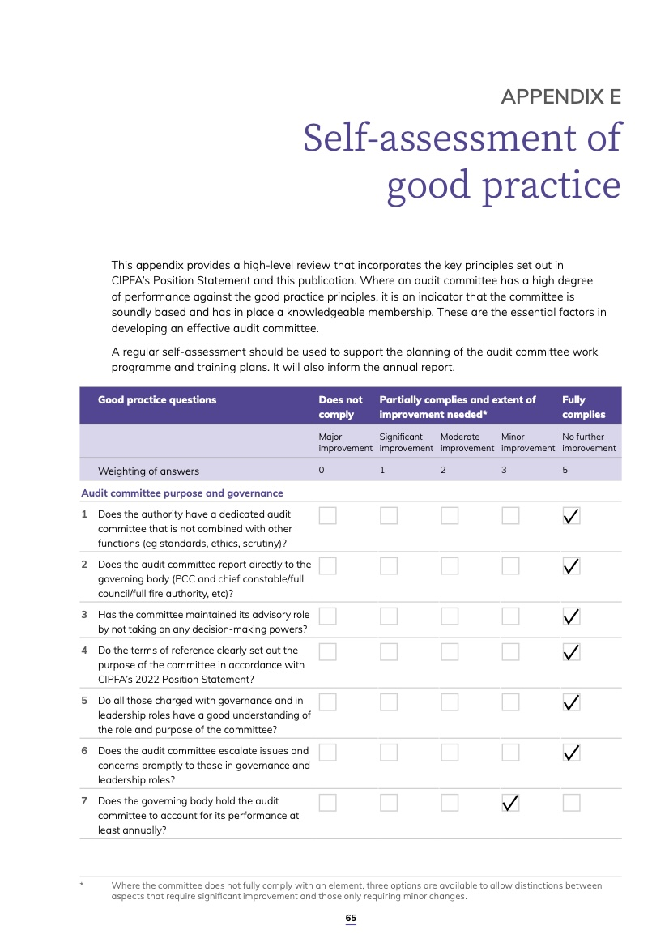
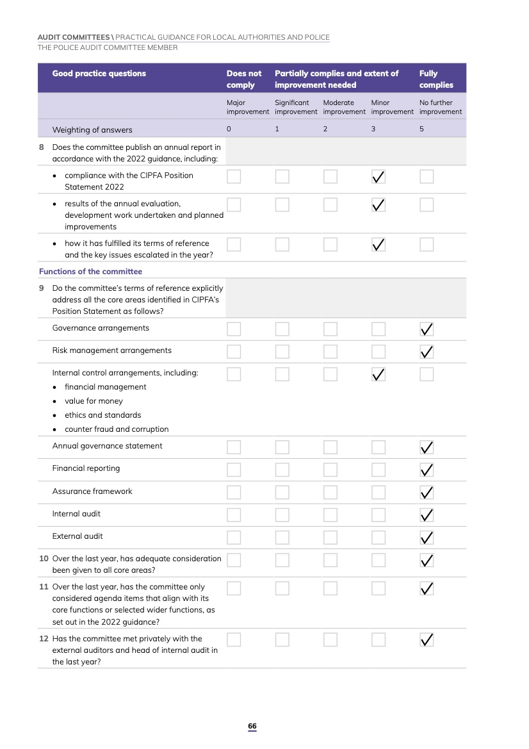
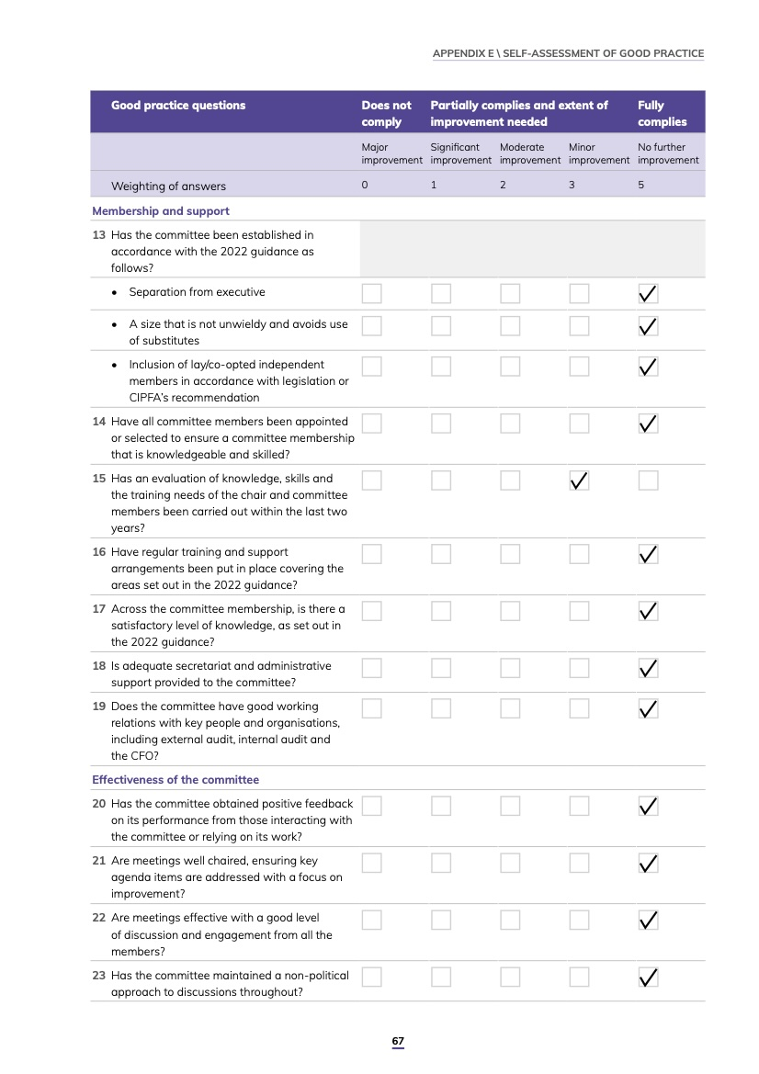

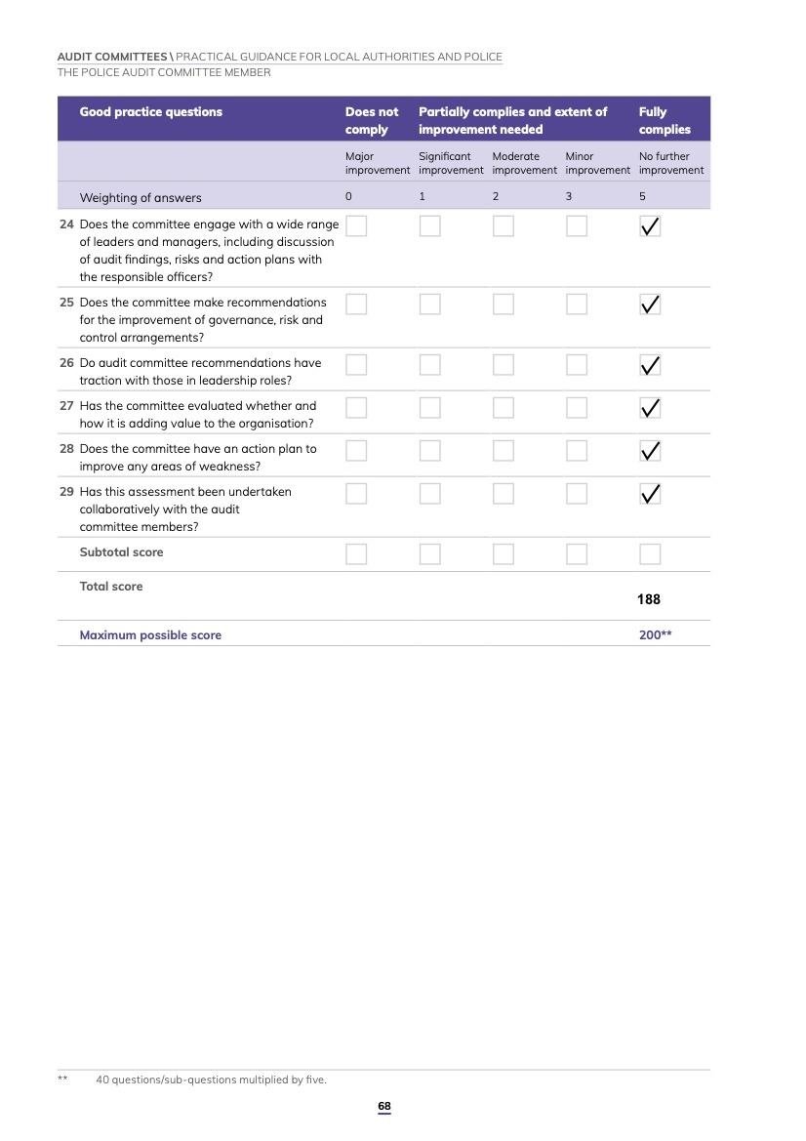

CIPFA’s Position Statement: Audit Committees in Local Authorities and Police (2018 edition)

