

SURREY POLICE POLICY MANAGEMENT UPDATE
Required for: | Joint Audit Committee September 2024
Security Classification: | Official
Handling information if required: | N/A
Suitable for publication: | Yes
Title: | Update on Policy Management
Version: | V3
Purpose: | To provide an update to the JAC on the Force policy management arrangements
ACPO / Strategic Lead: | Louise Sutton
National Decision Model compliance: | Yes
Date created: | 28th August 2024
Date to be reviewed:

AUTHOR:
Name: | Helen Bayliss
Job Title: | Department Head
Telephone number: | 07967988379
Email address: | helen.bayliss@surrey.police.uk
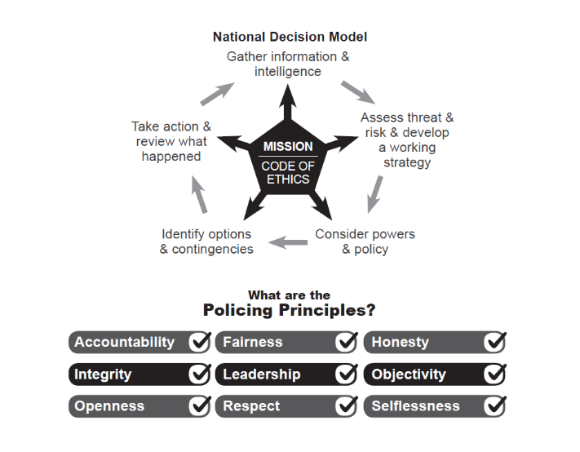

Policy Management  Surrey Police Policy Management Arrangements  To: Joint Audit Committee  From: Helen Bayliss  Date: 28 August 2024 | 

- Introduction
Policy and Procedure documents are owned by the Chief Constables of the Forces with maintenance devolved to the risk owner of the area of business. New documents and those requiring review must be considered for collaboration. If documents cannot be collaborated upon there must be sufficient rationale as to why. All standalone documents must be approved by the Head of Information Management. The details provided below outline the current process for the Policy Management Framework and the use adherence of, through to the development of a new Compliance and Assurance Framework.

- Creation and Review

Surrey Police has a Policy Management Framework that details the lifecycle of Policy Management through from creation, version control to eventual archiving. Policy and Procedures (all procedures must have an over-arching policy) are created on a standard template, to address an organisational direction for adherence to. They must be authorised by a Department Head and undergo a full consultation process when new and for any material changes to the policy on reviews. All policy and procedures are subject to a review process and they are reported at the Security and Information Management Board for overdue/outstanding reviews and now into the Organisational Reassurance Board if an overdue Policy presents as an organisational risk (assessed by Information Management). This process is robust by design, having been subject to independent reviews. The ‘communication’ of Policy is reliant on the standard mechanism of Routine Orders (with the option of Policy owners creating their own communication plans as necessary.
Information Management identified an opportunity with the Policy Management Framework, to allow for the tightening and grip on the latter part of the current offering regarding the publication of Policy, to enhance compliance opportunities. This essentially is converting the existing Policy environment to the M365 Platform and utilising the document management function.
This will allow for several things to happen in addition to the above process. It will allow for the process of creation, reviews and updating to be automated. The environment will be mobile friendly and allow for different push and pull of policy communications to be completed i.e. need to know policies verses when you need to know scenarios. It will also allow for auditing of ‘views’ and reporting organisationally as to the reach of policies and procedures to allow for confidence margins to be developed (in the future) as what is an acceptable threshold for knowledge of any one particular policy within the organisation.
This in turn will allow authors/policy owners to consider if any further communication options are required aside from Routine Orders to promote its use/awareness of, using an evidence base. It will also allow for the Force to have much more oversight and grip of the use/frequency of use of its policies. The user requirements have been completed with agreement and working jointly with Sussex (this is a Surrey led initiative). We are awaiting sign off at the next M365 Optimisation Board (19th September 2024) to ensure the resources to develop are assigned. The creation and realisation of this is expected by the end of the financial year.

- Use of and Adherence

Currently, the Force has several indicators to ensure the of use of (policy) and adherence to them, examples being:

3.1 Op Falcon, addressing investigative standards, through from correct template use, adherence with crime recording standards, investigative frameworks, to the application of the correct outcome, with direct feedback being issued.
3.2 Force Audit Team is in place to audit against the strategic crime plan, signed off yearly at the Crime Data Integrity Board chaired by the Deputy Chief Constable (DCC), the audit areas will reference back for adherence to policy, as per the targeted review area of focus, with feedback provided via the Force Performance Teams or directly for specialist units.
3.3 External Audit will audit against Surrey Police’s more corporate suite of Policies i.e. risk management for assurance and monitored via the Organisational Reassurance Board, again chaired by the DCC.
3.4 Risk Management more broadly will also consider Policy requirements when dealing with risks and issues as well as areas for improvements and recommendations. When Policy forms part of the response or mitigation it is further considered via the risk assurance process.
3.5 Inspectorate regimes across Policing, this can be from His Majesty’s Inspectorate of Constabulary and Fire & Rescue Services (HMICFRS), to Investigatory Powers Commissioner's Office (IPCO), the Information Commissioner's Office (ICO), Ofsted, Biometrics and Surveillance Commissioner, this is not an exhaustive list, will utilise the Force’s policies as the backdrop for any inspection activity to assess against reality verses expectation and requirements, again with findings managed through the Keto Risk Management system until sign of and assurance.
3.6 People data presented to the DCC, i.e., from People Services (complaints, civil claims) through to Professional Standards Department (PSD) data (complaints, litigation, investigations), all serve to provide a thematic view of Policy compliance and deviation from policy, either in the positive or otherwise.
3.7 Across Surrey Police, the Force has the annual integrity check with line managers having bespoke conversations around work-based behaviours as well as the Focus assessment process and annual vetting assurances. Whilst it is incumbent on everyone to read Routine Orders weekly, where policy updates are published as part of their contracted personal responsibility, this will be supported by line management structures, ensuring key updates are disseminated to staff as appropriate.
3.8 Some policies have trialled a ‘sign up’ process i.e. the Domestic Abuse Policy, where officers were asked to verify, they had read and understood the policy. This is not appropriate in every instance of policy management but is a method that is available to the Force in the right circumstance i.e., a focused prioritisation. Further examples being the Security Matters Policy. These however are usually ‘one-time’ events. On an annual basis there is a suite of mandatory College Learn packages, these relate to the Force agreed mandatory areas of priority linked to policy (Data Protection, PSD policies as examples). This is tracked and reported into Senior Management Teams (SMT) via the Human Resources (HR) Business Partners to ensure compliance and also serves as an additional pathway to enable policy requirements to be read, understood, and monitored.

- Compliance and Assurance

With the introduction of the new Policy Management Database and the opportunities this provides, this has allowed for a more holistic approach to Compliance and Assurance to be considered and developed. Using Policy Compliance as a basis, but also stretching the thinking to incorporate more; compliance with how we should be operating, doing all elements of what we are required to do as an organisation, both corporately and operationally.
This fundamentally then starts to form a detailed response to the requirement under Our Plan to enable the Force to not only judge how compliant we are as an organisation as a whole, but how we effectively assure ourselves of this.
Information Management have essentially undertaken the action to build what will be an Assurance and Compliance Framework for the Force – this will be an overarching Framework to for example Policy Management, Data Quality all the way through to Crime Management (essentially where a/any standard is set).
Whilst the aforementioned indicators are always useful, they are very much ‘standalone’ in how they are viewed, this Assurance and Compliance Framework, will provide for the opportunity for metrics to be assigned and the total picture to be viewed. This is not an insignificant piece of work and will be iterative in its development.
This in turn supports the development in the compliance approaches taken over the last year, for example in Crime Data Integrity, the HMICFRS issued areas for improvement to the Force, recorded as such on our Risk Management System and have assurance mechanisms through Board oversight with Chief Officers to track improvements supported by the Force Audit team.
The Business Intelligence team are continually developing new dashboards, most significant currently is the development of a Crime Management Dashboard, that will provide specific data on compliance at all levels across the organisation, which will support the Falcon Board, but also allow supervisors and managers to assess for compliance improvements, for Investigation Standards, through the Victims Code Compliance and Data Quality.
Following the SIAP audit, the Terms of Reference of the Organisational Reassurance Board (ORB) have been refreshed by the Strategic Governance Team, with clear expectations of the purpose of the meeting and of participants. Corporate Development have also mapped and augmented our assurance escalation points into ORB that provides absolute clarity on all the Assurance Boards (i.e. ACC Accountability Board).
The Assurance and Compliance Framework, that is currently in development and will consist of four main pillars:
- Goals and Objectives

- Processes and Systems
- Culture and Leadership
- Performance Metrics
The Assurance and Compliance Framework is set to be the overarching framework for the Force, detailing, how, what why and when both tactically and strategically. It will allow for clarity of purpose through to developed metrics that the Force will be able to assess itself against. The opportunity to join up performance reporting is reliant on technical development, however this in of itself is not a barrier to creating the Framework and the intent.
It also by default provides officers and staff with a clear roadmap of expectations in one place and transparency on how compliance is monitored by what mechanisms, how and how frequently – which is the gap that was identified. In such a fast paced environment with competing demands, telling/informing isn’t enough, consistency of message and compliance will then provide for assurance. As alluded to this will need to be iterative, however for new Policy (in its broadest sense) the requirement will be the organisation must identify and/or develop how it is to measure compliance, moving away from limited assurance approaches i.e. thematic reviews. This will be updated in the Policy Management Framework once the development has been completed and consultation of the Policy review concluded.

- Summary

To conclude, we would welcome the opportunity once the Compliance and Assurance Framework is ready for consultation to present to JAC members as part of this process, to ensure we have exploited all available opportunities.

Appendix – For Information:

Policy, Authorised Professional Practice (APP) and the National Decision Model (NDM). Policy and Procedure govern most of the tasks the Force undertakes to carry out its roles.

- A policy is a short statement of Surrey Police’s intention and/or goal; a 'what' document

- A procedure describes the major tasks required to achieve the objective/goal outlined in the policy. They contain mandatory instruction describing what processes need to be followed. A procedure is the 'how' document. It is quite normal to have more than one procedure sharing the same policy.

The Forces hold Policy & Procedure documents in two categories.
- Where they are required through Acts of Parliament e.g.

    - UK General Data Protection Regulations (UKGDPR)
    - Data Protection Act 2018
    - Health & Safety at Work Act 1974
    - Freedom of Information Act 2000

- Where they are required by the Forces to explain what the Force must and must not do to minimise risk.

APP-
Where APP is available it will be followed by the Forces unless there is deviation. In this instance the Forces will write their own policies. Where APP is referred to it must be hyperlinked, sections of text must not be copied.
NDM-
Where policies are not available through the respective Forces’ database and guidance not available on the intranet, officers and staff must use the NDM along with appropriate risk assessments e.g. THRIVE (Threat, Harm, Risk, Investigation, Vulnerability and Engagement), SCARF (Single Combined Assessment of Risk Form) / DASH (Domestic Abuse, Stalking and Harassment) / SST (Risk Identification Checklist for use in Stalking and Harassment Cases) / HARA (Hate & ASB Risk Assessment).

