

OFFICE OF THE POLICE & CRIME COMMISSIONER FOR SURREY & SURREY POLICE

Internal Audit Progress Report March 2025

Contents:
- Purpose of report 3
- Performance dashboard 4
- Analysis of ‘Live’ audit reviews 6
- Rolling work programme 9

Purpose of report
Internal audit reviews culminate in an opinion on the assurance that can be placed on the effectiveness of the framework of risk management, control and governance designed to support the achievement of management objectives of the service area under review.
CIPFA have recommended standardising the terminology and definitions used in internal audit engagements across the whole of the public sector and have published a standard set of opinions and supporting definitions for internal audit service providers to use. To ensure we continue to conform to the best practice principles, we have adopted the standard definitions. The assurance opinions are categorised as follows:
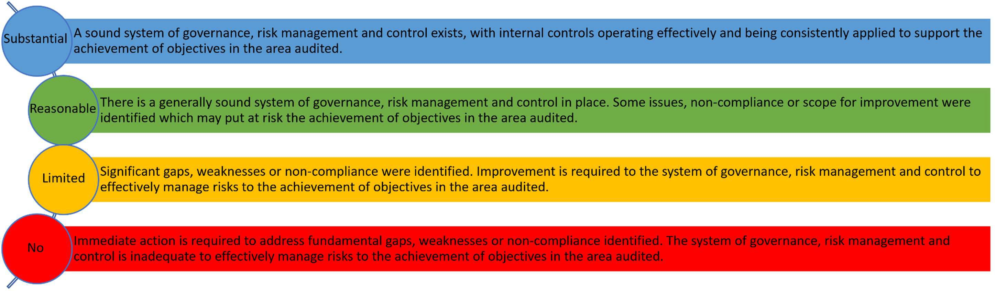

* Some reports listed within this progress report (pre 2020/21 audit plan) refer to categorisations used by SIAP prior to adoption of the CIPFA standard definitions, reference is provided at Annex 1.

Performance dashboard


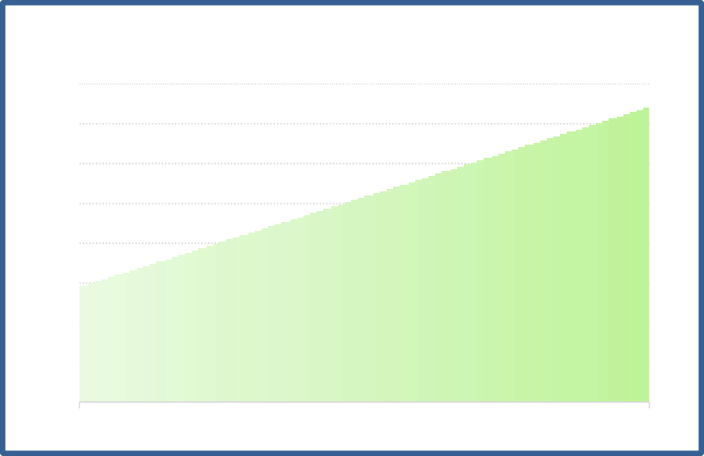
30%
Complete
33% of
revised plan delivered to to least draft report
70%
Work in Progress
0%
Yet to Commence
Stakeholder Satisfaction Survey Results
100%
98%
96%
94%
92%
90%
88%
86%
84%
Target
Actual

Days Delivered

 | Surrey 2024/25 plan | Joint Sussex and Surrey  2024/25 plan
Original Plan Days | 103 | 350
Revised Plan Days | 103 | 350
Days delivered | 91 | 295
Percentage of revised  plan delivered | 94% | 84%

Compliance with Public Sector Internal Audit Standards
An External Quality Assessment of the Southern Internal Audit Partnership was undertaken by the Institute of Internal Auditors (IIA) in September 2020. The report concluded:
‘The mandatory elements of the IPPF include the Definition of Internal Auditing, Code of Ethics, Core Principles and International Standards. There are 64 fundamental principles to achieve with 118 points of recommended practice. We assess against the principles.
It is our view that the Southern Internal Audit Partnership conforms to all 64 of these principles.
We have also reviewed SIAP conformance with the Public Sector Internal Audit Standards (PSIAS) and Local Government Application Note (LGAN).
We are pleased to report that SIAP conform with all relevant, associated elements.’
- Analysis of ‘Live’ audit reviews (as at 6 March)
Audit Review | Report Date | Audit Sponsor | Assurance Opinion | Total Management  Action(s) | Not Accepted | Not Yet Due | Complete/ Retired** | Overdue
 |  |  |  |  |  |  |  | L | M | H
IT Virtualisation* | May 22 | COO | Limited | 8 | 0 | 0 | 8
ERP – Legacy IT Risks Oracle People Solutions | Sep 22 | COO | No Assurance | 11 | 0 | 0 | 5 |  |  | 6
Strategy and arrangements for delivery of training to meet future  need | Aug 22 | DPS | Reasonable | 4 | 0 | 0 | 3 |  | 1
Duty Resource Planning | Sep 22 | ACC | Limited | 9 | 0 | 0 | 8 |  | 1
Operating Systems Management | Dec 22 | COO | Limited | 17 | 0 | 0 | 16 |  | 1
Vulnerability Management | Jul 23 | COO | Reasonable | 12 | 0 | 0 | 11 | 1
Database Management | Sep 23 | COO | Limited | 21 | 1** | 0 | 19 |  | 1
SSP Vehicle Recovery Process | Jan 24 | ACC | Limited | 11 | 0 | 0 | 9 | 2
SSP Armouries (storage and  management) | Feb 24 | ACC | Limited | 13 | 0 | 3 | 10
SSP Business Continuity (SAP/ Oracle) | Feb 24 | CFO | Limited | 14 | 0 | 0 | 12 | 1 | 1
Surrey Payroll | Feb 24 | CFO | Reasonable | 5 | 0 | 1 | 4
Surrey RoadSafe Partnership | Apr 24 | ACC | Reasonable | 11 | 0 | 0 | 6 | 2 | 3
SSP Estates and Facilities Management | May 24 | CFO | Limited | 16 | 0 | 3 | 9 |  | 1 | 3
SSP Contract Management - Capital | May 24 | CFO | Reasonable | 3 | 0 | 1 | 2
SSP Redundancy Process and  Payments* | May 24 | DPS | Limited | 8 | 0 | 0 | 8
SSP IT Major Incident Management | Jun 24 | COO | Reasonable | 6 | 0 | 0 | 4 |  | 2
SSP Learning & Development  Mandatory Training 2023/24 | June 24 | DPS | Limited | 6 | 0 | 4 | 2
SSP Flexible Retirements* | Jun 24 | ACC | Reasonable | 10 | 0 | 0 | 10

Surrey Perpetrator Pathways – Domestic Abuse – Governance and  Roles & Responsibilities | Jul 24 | ACC | Reasonable | 3 | 0 | 0 | 0 |  | 3
SSP Supply Chain Security  Management | Jul 24 | COO | Reasonable | 14 | 0 | 1 | 13
Surrey - Data Storage and Backup | Jul 24 | COO | Reasonable | 5 | 0 | 0 | 1 | 3 | 1
SSP Data Protection Impact  Assessments* | Oct 24 | DCC | Reasonable | 8 | 0 | 0 | 8
SSP Legacy Application Management | Nov 24 | COO | Reasonable | 4 | 0 | 2 | 2
Management Information –  dashboard development and use | Jan 25 | DCC | Reasonable | 6 | 0 | 3 | 3
SSP Use of Air Support (Drones) –  Governance* | Jan 25 | ACC | Substantial | 0 | 0 | 0 | 0
SSP NPAS - National Air Helicopter Feb 25 ACC Reasonable 5 0 3 1  Service – Use of Allocated Hours |  |  |  |  |  |  |  |  | 1
SSP Management of Fleet Vehicles | Feb 25 | CFO | Reasonable | 2 | 0 | 2 | 0
SSP Transformation Savings  Governance* | Feb 25 | CFO | Substantial | 0 | 0 | 0 | 0
Estates Strategy - Redevelopment of Mount Browne* | Feb 25 | DCC | Substantial | 0 | 0 | 0 | 0
Crime Management – Organised  Crime Groups Processes | Feb 25 | ACC | Reasonable | 6 | 0 | 6 | 0
Violence Against Women and Girls -  relentlessly pursuing offenders | Feb 25 | ACC | Substantial | 0 | 0 | 0 | 0
Total |  |  |  |  |  |  |  | 9 | 16 | 9
* Denotes audits where all actions have been completed since the last progress report.
** Denotes where actions are retired/pending retirement.

Audit Sponsor (Director)
Chief Finance Officer | CFO

Deputy Chief Constable | DCC
Assistant Chief Constable | ACC
Chief Operating Officer | COO
ACO Director People Services | DPS

Rolling Work Programme

2023/24 Audit Plan – Remaining Audits

Audit Review | Audit Sponsor | Scoping Terms of  Reference Issued | Fieldwork Draft  Report Issued | Final Report Issued | Assurance Opinion | Comment / Previous Opinion
Shared Plan with Sussex Police
Data Protection Impact Assessments | DCC | ✓ ✓ | - 12.08.24 | 17.10.24 | Reasonable
Legacy Application Management | COO | ✓ ✓ | - 20.11.24 | 28.11.24 | Reasonable

2024/25 Audit Plan

Audit Review | Audit Sponsor | Scoping | Terms of Reference  Issued | Fieldwork | Draft Report  Issued | Final Report  Issued | Assurance Opinion | Quarter | Comment / Previous Assurance Opinion
Collaborated Plan
Use of Air Support (Drones) -  Governance | ACC | 17.06.24 | 02.08.24 | 04.11.24 | 21.01.25 | 30.01.25 | Substantial | Q1
NPAS - National Air Helicopter Service –  Use of Allocated Hours | ACC | 02.08.24 | 09.09.24 | 07.10.24  18.11.24 | 9.12.24 | 03.02.25 | Reasonable | Q2
Management of Fleet Vehicles | CFO | 01.08.24 | 05.08.24 | 09.09.24  18.11.24 | 15.11.24 | 10.02.25 | Reasonable | Q2
Health and Safety | DCC | 17.10.24 | 24.02.25 |  |  |  |  | Q2 | Requested by Force to move to Q4 due to clash with a H&S

Audit Review | Audit Sponsor | Scoping | Terms of  Reference Issued | Fieldwork | Draft  Report Issued | Final  Report Issued | Assurance Opinion | Quarter | Comment / Previous Assurance Opinion
Investigation. Scoping meeting 27 Jan. Scoping meeting with Surrey 11 Feb. Testing to start 23 March.
2021-22 – Reasonable and 2023-24 Reasonable
Transformation Savings Governance | CFO | 31.07.24 | 18.09.24 | 19.12.24  03.02.25 | 07.02.25 | 11.02.25 | Substantial | Q2
Crime Management – Organised Crime  Groups Processes | ACC | 27.08.24 | 09.09.24 | 17.10.24  06.01.25 | 15.01.25 | 26.02.25 | Reasonable | Q2
Business Continuity Planning | DCC | 24.10.24 | 26.11.24 | 16.12.24  07.03.25 | 18.03.25 |  |  | Q3 | Scoping meeting 4 Nov, draft ToR issued 26 Nov. Close of audit 12 March.  2020-21 -Reasonable and  2023-24 - Limited
Counter Fraud Work  - Advisory | ACC | 28.10.24 | 09.01.24 | 03.03.25 |  |  |  | Q3 | First Review
Dog School – Income Generation | ACC | 02.12.24 | 17.12.24 | 24.01.25 |  |  |  | Q3 | Close of audit 3 April.  First Review
Armouries – Storage and Management | ACC | 19.12.24 | 06.02.25 | 10.03.25 |  |  |  | Q4 | Scoping meeting 29 Jan. Draft ToR issued 6 Feb. Final ToR 7 Feb. Testing delayed to 10 Mar due to force availability. Close meeting booked for 22 Apr.

Audit Review | Audit Sponsor | Scoping | Terms of  Reference Issued | Fieldwork | Draft  Report Issued | Final  Report Issued | Assurance Opinion | Quarter | Comment / Previous Assurance Opinion
2023-24 - Limited
Recruitment | DPS | 14.11.24 | 17.12.24 | 13.01.25  10.03.25 | Q4 |  |  |  | Moved to Q3 to accommodate H&S being moved to Q4.  Testing complete, close meeting 27 Mar.  2020-21 - Reasonable
Duty of Care Risk Assessments | ACC | 23.12.24 | 03.02.25 |  | Q4 |  |  |  | Scoping meeting 21 Jan. Draft and Final ToR 3 Feb. Testing programme being prepared.  First Review
Estates and Facilities – Recovery Plans | CFO | 23.12.24 | 11.02.25 |  | Q4 |  |  |  | Scoping meeting 20 Jan. Draft ToR issued 11 Feb. Testing programme being prepared.  First Review
Joint Procurement | CFO | 08.01.25 | 07.03.25 |  | Q4 |  |  |  | Initial scoping meeting 17 Jan.  Agreed to carry out late March, Scoping meeting 3 March.  2020-21 - Reasonable
Collaborated Plan - IT
Software Licensing | COO | 07.06.24 | 22.08.24 | 13.12.24 | Q1 |  |  |  | Audit testing underway.  First Review

Audit Review | Audit Sponsor | Scoping | Terms of  Reference Issued | Fieldwork | Draft  Report Issued | Final  Report Issued | Assurance Opinion | Quarter | Comment / Previous Assurance Opinion
Service Transition | COO | 21.06.24 | 05.09.24 | 12.12.24 |  |  |  | Q1 | Audit testing underway.  First Review
IT Disaster Recovery and IT Service  Continuity | COO | 26.11.24 | 5.12.24 | 20.01.25 |  |  |  | Q2 | Audit testing underway.  First Review
Data Centre Facilities and  Security | COO | 22.01.25 | 06.03.25 |  |  |  |  | Q2 | Scoped  First Review
Application Management NICE  Investigate | COO | 06.02.25 | 26.02.25 |  |  |  |  | Q3 | Scoped  First Review
High Privilege Access  Management | COO | 11.12.24 | 15.01.25 |  |  |  |  | Q3 | First Review
Surrey Plan
Estates Strategy -  Redevelopment of Mount Browne | CFO | 14.05.24 | 02.07.24 | 08.10.24  16.12.24 | 21.01.25 | 10.02.25 | Substantial | Q1
Management Information – dashboard development and  use | DCC | 20.05.24 | 22.08.24 | 23.09.24  24.10.24 | 13.11.24 | 14.01.25 | Reasonable | Q1
 |  |  |  |  |  |  |  |  | Delayed due to auditor
Missing Person Compliance | ACC | 23.05.24 | 18.06.24 | 16.12.24 |  |  |  | Q1 | sickness and change of staffing  at Force. Audit testing
 |  |  |  |  |  |  |  |  | underway.

Audit Review | Audit Sponsor | Scoping | Terms of  Reference Issued | Fieldwork | Draft  Report Issued | Final  Report Issued | Assurance Opinion | Quarter | Comment / Previous Assurance Opinion
First review
Violence Against Women and Girls - relentlessly  pursuing offenders | ACC | 10.09.24 | 08.10.24 | 22.11.24  19.12.24 | 29.01.25 | 26.02.25 | Substantial | Q2
Right Care, Right Person | ACC | 28.10.24 | 05.12.24 | 03.03.25 |  |  |  | Q3 | Key contact not available until mid-Jan. Detailed scoping held 23 Jan. Testing underway.  First review
PCC General and Statutory Duties – Assurance Framework | CFO (OPCC) | 04.11.24 | 11.12.24 |  |  |  |  | Q3 | Scoping meeting 14 Nov. Detailed scoping meeting 23 Jan.  First review
Adult Abuse Investigation – Governance and Reporting | ACC | 16.01.25 | 24.02.25 |  |  |  |  | Q4 | Scoping meeting arranged for 30 Jan, postponed to 13 Feb. Detailed scoping postponed from 12 Mar to 25 Mar due to client sickness.  First review

The following variations have been made to the 2024/25 internal audit plan since it was presented to the Joint Audit Committee in April 2024 and changes since the last JAC meeting are marked with *.

Collaborated Plan
Audit reviews removed from the plan
Violence Against Women and Girls - relentlessly pursuing offenders | Removed from the SSP plan to be considered under individual force plans due to differences in processes in this area. Propose to undertake Surrey audit in Q3 and undertake Sussex in either Q4 or 2025/26.
Joint Force Vetting | Audit cancelled in October due to clash with HMICFRS inspection, along with the Angiolini Inquiry in Sussex examining some of the same areas. Propose to undertake in 2025/26 with a focus on areas for improvements identified by the inspections.
IT Health Check Remediation* | Audit removed from the 2024/25 plan as the Health Check has only just started so there would not be enough to audit at the current time. The audit will be undertaken as part of the 2025/26 audit plan.
Audit reviews added to the plan
None

Surrey Police Plan
Audit reviews removed from the plan
None
Audit reviews added to the plan
Violence Against Women and Girls - relentlessly pursuing offenders | Moved from the SSP plan to the Surrey plan due to difference in processes between Surrey and Sussex.

