
Required for: | Joint Audit Committee (JAC) March 2025
Security Classification: | Official
Handling information if required: | n/a
Suitable for publication: | Yes
Title: | 2024/25 Treasury Management report for Qtr 3
Version: | n/a
Purpose: | To review the quarterly activity and performance of the treasury management function for the period to 31st December 2024.
ACPO / Strategic Lead: | PCC
National Decision Model compliance: | Yes
Date created: | 27 February 2025
Date to be reviewed:
AUTHOR:
Name: | Kelvin Menon
Job Title: | PCC Treasurer
Telephone number: | 01483 638724
Email address: | Kelvin.Menon@surrey.police.uk


Recommendation(s) -

The JAC is asked to note and comment on the report.

Summary:

This report includes a summary of treasury management performance for the first 9 months of 2024/25.

Conclusions

The PCC has achieved a return on investments in line with bank rates without exposing funds to undue levels of risk. Compliance with the Prudential Indicators will be confirmed at the year end.

Legal Implications

The PCC is required to comply with requirements of the CIPFA Prudential Code. This only requires reporting at the 6th and 12th month intervals so this paper is in addition to those requirements.

Equalities Implications

There are no equalities implications arising from this report.

Risks

Risks are minimised by undertaking all Treasury Management activity during the year in accordance with the approved Treasury Management Policy Strategy. The Policy prioritises risk over return, and this is reflected in the contract with SCC. Pooling funds with SCC and making only short-term overnight deposits minimises risks whilst achieving a reasonable return.

Appendices

1 – Commentary on PWLB Rates
2 – Economic Update

Background papers –
This document has been prepared with due regard to: -
PCC Treasury Management Strategy
CIPFA Prudential Code for Capital Finance in Local Authorities – 2018 edition
CIPFA Treasury Management in the Public Services: Code of Practice

Contact details -
Name: Ricardo Herrera-Delgado
Job Title: Head of Financial Accounting
Email address: ricardo.herrera-delgado@surrey.police.uk

Treasury Management – Statutory Requirements

- It is a requirement under The Local Authorities (Capital Finance and Accounting) (England) Regulations 2003 that bodies comply with the CIPFA Code of Practice for treasury Management. This is to ensure that comprehensive policies and practices are in place for the effective management and control of treasury management activities, including the effective management and control of risk.

- Treasury management is defined in the Code of Practice as “the management of the organisation’s investments and cash flows, its banking, money market and capital market transactions; the effective control of the risks associated with those activities; and the pursuit of optimum performance consistent with those risks.

- Although there is no requirement for a 9 month update on treasury performance this report is provided to give additional information.

Treasury Management Transactions for first 9 months of 2024/25

- The Police and Crime Commissioner (PCC) operates a balanced revenue budget, which means its income (and hence its cash received) will be equal to its expenditure (cash paid out). However, due to timing differences between when cash received and paid out this can lead to surplus cash being held. The PCC also holds reserves which are represented by surplus cash. Treasury management operations ensure firstly there is adequate cashflow available to meet liabilities as they arise and secondly that surplus cash is invested to provide a return for the PCC. The priority however is to ensure security and liquidity before considering optimising investment return.

Short Term Investment
- The PCC has a service level agreement with Surrey County Council (SCC) for the provision of Treasury Management Services. Surplus cash held by the PCC is lent at the end of each working day to SCC who then pool it with their own surplus funds for investment in overnight money market deposits. The cash is then returned to the PCC each morning. Currently SCC only invest in low-risk counterparties for short overnight deposits. Risks are pooled with SCC in that were a counterparty to default the loss to the PCC would be in the ratio of PCC funds against total funds invested. There have been no defaults during the year and all funds have been returned to the PCC as agreed.

Investment Returns
- As part of the agreement SCC guarantees to pay to the PCC interest quarterly equivalent to the higher of:
- SCC weighted average quarterly investment rate.
- SONIA minus 0.1082%
- Bank of England Base rate

During the first nine months of the year 191 individual loans were made to SCC for which interest of £2.297m was paid giving an average interest rate of 4.96%. This compares with only £1.936m interest at an average rate of 5.28% for the same period last year. The better performance in 2024/25 has been driven mainly by the higher investment balances and investments rates. The chart below shows the change in the Bank of England base rate over time:

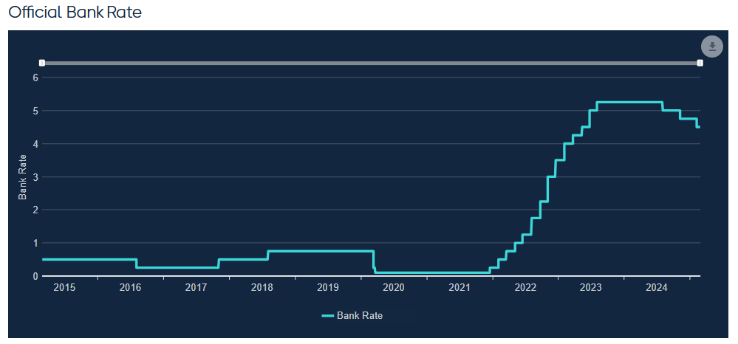
Future returns are likely to fall as interest rates reduce and balances are used to support projects such as the Surrey Estates Strategy – New Head Quarter.
- The tables below show the %interest rate returns and actual returns over number of years:

Treasury Management Costs
- SCC recharged a proportion of the costs of its treasury management team for the provision of the treasury service it provides to the PCC. This is estimated to be £22,500 for 2024/25, which is the same as 2023/24. This covers the daily sweeping of accounts, investing of surplus funds and return of funds each morning. Twice yearly contract monitoring meetings are also held during the year with SCC treasury officers. No brokers fees were paid during the year as all Treasury Management activity was undertaken by SCC on the PCC’s behalf.

Short Term Borrowing
- No short-term external borrowing was required during the third quarter of 2024/25 as the PCC had adequate cash balances to meet its liabilities.

Long Term Borrowing
- The only long term loan the PCC holds was taken out in March 2019 and is a 30-year loan from the Public Works Loan Board (PWLB) at a fixed interest rate of 2.34% to support the Estates strategy. This is being repaid in equal instalments over the term of the loan and the balance on the 31st of March 2024 was £13m.

- It is worth noting that legally borrowing can only be taken out to fund capital. If it is required for revenue then this can only be by way of a capital directive issued by the Minister. Furthermore, as the PCC has no general power of competence borrowing can only be taken out for a Policing purpose. i.e. It cannot be used for say property investment even if the income this generates may be used for a Policing purpose.

Future Borrowing Requirements
- The delivery of the Estates strategy, and particularly the new HQ, is likely to lead to a requirement for additional borrowing. This has been reflected in the borrowing limits in the future Prudential Indicators. The PCC is likely to fund this borrowing using a mixture of internal borrowing and longer term PWLB loans. Any borrowing will need to be affordable in that both the interest and Minimum revenue Payment (MRP) will need to be funded from revenue. It will also have to strike a balance between lower interest rates and cost certainty over the period funds are required for.

- Although the PCC can borrow money from any financial institution, such as a bank, most loans come from the Public Works Loan Board (PWLB) part of the Debt Management office at the treasury. PWLB interest rates are pegged to UK gilt rates as follows:
    - PWLB Standard Rate is gilt plus 100 basis points (G+100bps)
    - PWLB Certainty Rate (on capital plans submitted at the start of the year) (GF) is gilt plus 80 basis points (G+80bps)
    - PWLB Local Infrastructure Rate is gilt plus 60 basis points (G+60bps)
    - In addition, the UK Infrastructure Bank will lend to local authorities that meet its scheme criteria at a rate currently set at gilt plus 40bps (G+40bps).

- The lowest and highest PWLB interest rates over the period for various terms of loans are shown in the table below. A commentary from Treasury Advisors on how PWLB rates are set, and possible trends is attached as Appendix 1
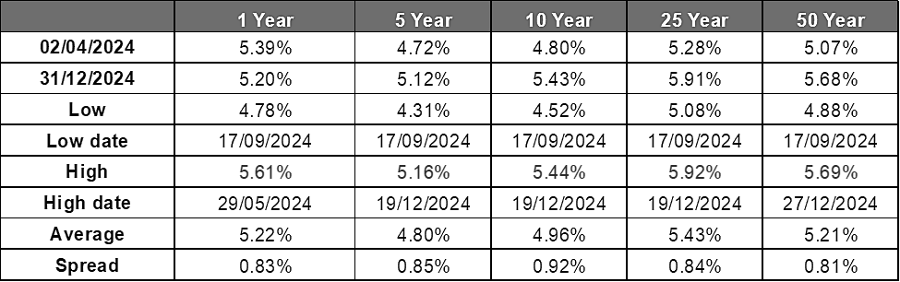

Compliance with Prudential Indicators

- The PCC approved the prudential indicators for 2024/25 early in 2024. These set out the parameters for Minimum Revenue Payment (MRP), Investments and borrowing. Compliance with these will be assessed at the year end.

For 2024/25 MRP has been provided in the budget on borrowings in accordance with the Prudential Code and information on this is set out in Appendix 3.

Economic Update

- A review of economic performance to date and outlook prepared as background information by Treasury advisors is attached as Appendix 2.

Risks

- Risks are minimised by undertaking all Treasury Management activity during the period in accordance with the approved Treasury Management Policy Strategy. The Policy prioritises risk over return, and this is reflected in the contract with SCC. Pooling funds with SCC and making only short-term overnight deposits minimises risks whilst achieving a reasonable return.

APPENDIX 1 – PWLB Certainty Rates to 31st December 2024 (9 months)

- PWLB rates are based on gilt (UK Government bonds) yields through HM Treasury determining a specified margin to add to gilt yields. The main influences on gilt yields are Bank Rate, inflation expectations and movements in US treasury yields. Inflation targeting by the major central banks has been successful over the last 30 years in lowering inflation and the real equilibrium rate for central rates has fallen considerably due to the high level of borrowing by consumers: this means that central banks do not need to raise rates as much now to have a major impact on consumer spending, inflation, etc. This has pulled down the overall level of interest rates and bond yields in financial markets over the last 30 years. Indeed, in recent years many bond yields up to 10 years in the Eurozone turned negative on expectations that the EU would struggle to get growth rates and inflation up from low levels. In addition, there has, at times, been an inversion of bond yields in the US whereby 10-year yields have fallen below shorter-term yields. In the past, this has been a precursor of a recession.
- As a general rule, short-dated gilt yields will reflect expected movements in Bank Rate, whilst medium to long-dated yields are driven primarily by the inflation outlook.
PWLB maturity certainty rates (gilts plus 80bps) year to date to 31st December 2024
- Gilt yields and PWLB certainty rates were less volatile than at this time last year. Overall, the 10, 25 and 50-year part of the curve endured a little volatility but finished September very much as it started in April.
- Where there was some movement downwards, this came in the shorter part of the curve as markets positioned themselves for Bank Rate cuts in the second half of 2024 and into 2025, although the continued stickiness of inflation and the prevailing tight labour market is a concern for those looking for more sizeable falls ahead.
- At the beginning of April, the 5-year certainty rate was the cheapest part of the curve at 4.72% whilst the 25-year rate was relatively expensive at 5.28%. May saw yields at their highest across the whole curve.
- Conversely, 17 September saw the low point for the whole curve, with the 5-year certainty rate falling to 4.31% before rebounding to 4.55% by the end of the month. Similarly, the 50-year certainty rate fell to 4.88% but finished the month at 5.13%, slightly higher than at the start of April.
- At this juncture, we still forecast rates to fall back over the next two to three years as inflation dampens, although there is upside risk to our Bank Rate forecast at present. The CPI measure of inflation is expected to fall below 2% in the second half of 2025, however, and we forecast 50-year rates to stand at 4.20% by the end of September 2026. The major caveats are that there is considerable gilt issuance to be digested by the market over the next couple of years, and geo-political uncertainties – which are generally negative for inflation prospects – abound in Eastern Europe and the Middle East, in particular.
- Medium and longer-dated gilt yields, and therein PWLB rates, have moved significantly higher over the course of the financial year, culminating in long-term rates approaching levels last seen in 1998. The rise in medium to long-term yields has arisen because of several factors. Namely, the inflation outlook has become stickier than the market anticipated earlier in the year, with wages remaining somewhat elevated. (currently increases are c5% y/y) and the labour market tight (unemployment a little above 4% and job vacancies more than 800,000).
- Additionally, US Treasury yields have also risen prior to Donald Trump’s inauguration as US President on 20th January. Markets are nervous as to what the effect of deportation, tariff and tax-cutting policies will have on inflation. Given the impact US markets have globally, this is another contributing factor to the near-term rise in UK yields. The hope is that when the “unknowns” become known, markets will behave in a calmer fashion and yields fall back. But that is not certain.
- The table below shows the interest rate charged by the PWLB over the last few years for various loan periods. This is based on the “certainty rate” which is the one most likely to be offered to the PCC by the PWLB as it is offered for planned capital expenditure.

- It is worth noting that all the rates above are fixed for the entire period of the loan and that interest rates will vary depending on the repayment profile of the loan i.e. Equal repayment of principle, annuity or repayment at the end of the term. Whatever the repayment profile of the loan a Minimum Revenue Payment (MRP) must still be charged to revenue in line with statutory requirements. Furthermore, the PWLB does not undertake any due diligence before granting a loan – it is for the borrowing counterparty, usually the sec151 officer, to state that the prudential regulations have been complied with. i.e. The loan is for a lawful purpose and the public body can repay it.

APPENDIX 2 – Economic Update

- The following economic update has been prepared by Treasury advisors by way of background information. This was prepared before the Autumn budget and the US Election.
The Economy and Interest Rates
- The third quarter of 2024/25 (October to December) saw:
- GDP growth contracting by 0.1% m/m in October following no growth in the quarter ending September.
- The 3myy rate of average earnings growth increase from 4.4% in September to 5.2% in October.
- CPI inflation increase to 2.6% in November.
- Core CPI inflation increase from 3.3% in October to 3.5% in November.
- The Bank of England cut interest rates from 5.0% to 4.75% in November and hold them steady in December.
-10-year gilt yields starting October at 3.94% before finishing up at 4.57% at the end of December (peaking at 4.64%).
- The 0.1% m/m fall in GDP in October was the second such decline in a row and meant that GDP would need to rise by 0.1% m/m or more in November and December, for the economy to grow in Q4 rather than contract. With on-going concern over the impact of the October budget and drags from higher interest rates and weak activity in the euro zone, our colleagues at Capital Economics have revised down their forecast for GDP growth in 2025 to 1.3% (it was initially 1.8% in the immediate wake of the Budget.)
- This quarter saw the composite activity Purchasing Manager Index (PMI) dip below the level of 50 that separates expansion from contraction for the first time since October 2023. Although December’s composite PMI came in above this level, at 50.5, this was still consistent with the 0% rise in real GDP in Q3 being followed by a flat-lining, or potential contraction, in the final quarter of 2024. However, the economy is unlikely to be quite as weak as that given that the PMIs do not capture rises in government spending, but the data does underline the continued divergence in trends between the manufacturing and services sectors. The manufacturing PMI fell for its fourth consecutive month in December, from 48.0 in November to 47.3. That’s consistent with manufacturing output falling by 1.5% q/q in the final quarter of 2024 after flatlining through the summer months. This weakness in the manufacturing sector was offset by a rebound in the services sector. The services PMI rose from 50.8 in November to 51.4 in December, which is consistent with non-retail services output growth increasing from +0.1% q/q to +0.3% for October - December. This suggests that more of the recent slowdown in GDP is being driven by the weakness in activity overseas rather than just domestic factors. Additionally, the services output prices balance rose for the third consecutive month, from 55.4 in November to 56.9, showing signs that price pressures are reaccelerating.
- After rising by 1.4% q/q in July - September, the retail sector had a difficult final quarter of the year. Indeed, the bigger-than-expected 0.7% m/m fall in retail sales in October (consensus forecast -0.3% m/m) suggested that households’ concerns about expected tax rises announced in the Budget on 30th October contributed to weaker retail spending at the start of the quarter. The monthly decline in retail sales volumes in October was reasonably broad based, with sales in five of the seven main sub sectors slipping. However, the potential for seasonally adjusted sales to rise in November - if October's figures were impacted by the timing of the school half term – combined with a rebound in consumer confidence and rising real incomes, points to some promise to the final quarter of 2024The further easing in wage growth will be welcomed by the Bank of England as a sign that labour market conditions are continuing to cool. The 3myy growth rate of average earnings fell from 4.6% in June to 4.0% in July. On a three-month annualised basis, average earnings growth eased from 3.0% to 1.8%, its lowest rate since December 2023. Excluding bonuses, the 3myy rate fell from 5.4% to 5.1%.
- The Government’s October budget outlined plans for a significant £41.5bn (1.2% of GDP) increase in taxes by 2029/30, with £25bn derived from a 1.2% rise in employers’ national insurance contributions. The taxes are more than offset by a £47bn (1.4% of GDP) rise in current (day-to-day) spending by 2029/30 and a £24.6bn (0.7% of GDP) rise in public investment, with the latter being more than funded by a £32.5bn (1.0% of GDP) rise in public borrowing. The result is that the Budget loosens fiscal policy relative to the previous government’s plans - although fiscal policy is still being tightened over the next five years – and that GDP growth is somewhat stronger over the coming years than had previously been forecasted. By way of comparison, the Bank of England forecasts four-quarter GDP growth to pick up to almost 1¾% through 2025 (previously forecast to be 0.9%) before falling back to just over 1% in 2026.
- December’s pay data showed a rebound in wage growth that will likely add to the Bank of England’s inflationary concerns. The 3myy rate of average earnings growth increased from 4.4% in September (revised up from 4.3%) to 5.2% in October (consensus forecast 4.6%) and was mainly due to a rebound in private sector pay growth from 4.6% to 5.4%. Excluding bonuses, public sector pay stagnated in October and the 3myy rate fell from 4.7% to 4.3%.
- The number of job vacancies also fell again from 828,000 in the three months to October to 818,000 in the three months to November. This marks the first time it has dropped below its pre-pandemic February 2020 level of 819,000 since May 2021. Despite this, the Bank of England remains concerned about the inflationary influence of high wage settlements as well as the risk of a major slowdown in labour market activity.
- CPI inflation has been on the rise this quarter, with the annual growth rate increasing from 1.7% in September to 2.3% in October, before rising further to 2.6% in November. Although services CPI inflation stayed at 5.0% in November, the Bank had expected a dip to 4.9%, while the timelier three-month annualised rate of services CPI rose from 5.0% to 5.1%. That shows that there currently isn’t much downward momentum. Moreover, the wider measure of core CPI inflation rose from 3.3% to 3.5% in November. Both services and core inflation are currently at rates well above those consistent with the 2.0% target and are moving in the wrong direction. Capital Economics forecast that after dipping to 2.5% in December, CPI inflation will rise further in January, perhaps to 2.8%. Although CPI inflation is expected to be back at close to the 2.0% target by the end of 2025, given that a lot of the rise in inflation in the coming months will be due to base effects that won’t persist, the potential for a broader set of tariffs to arise from the US as well as the constant threat of geo-political factors to impact energy and food prices suggest risks remain very much to the upside.
- Throughout the quarter gilt yields have risen. The 10-year gilt yield increased from 3.94% at the start of October to 4.57% by the year end (and has subsequently risen to 4.64% early in 2025). As recently as mid-September 10-year gilt yields were at their low for the financial year, but since then, and specifically after the Budget at the end of October, yields have soared. Overall, the reaction to the UK Budget highlights how bond markets are both fragile and highly attentive to news about the fiscal outlook.
- The FTSE 100 started off this quarter at 8,276, before finishing up at 8,121. In particular, UK markets have continued to fall further behind US equities, a trend which has accelerated since Trump’s election victory in November, partly due to the UK stock market being less exposed to AI hype, and it being weighed down by its relatively large exposure to the energy and materials sectors.
MPC meetings: 9 May, 20 June, 1 August, 19 September 2024, 7th November & 18th December 2024
- On 7 November, Bank Rate was cut by 0.25% to 4.75%. The vote was 8-1 in favour of the cut, but the language used by the MPC emphasised “gradual” reductions would be the way ahead with an emphasis on the inflation and employment data releases, as well as geo-political events.
- At the 18 December meeting, another split vote arose. Members voted 6-3 to keep Bank Rate on hold at 4.75%, but dissenters (Dhingra, Ramsden and Taylor) were keen for rates to be cut further as concerns over the slowing down of the UK economy took root, despite near-term inflation fears remaining.
- The MPC again stated that “a gradual approach” to rate cuts “remains appropriate” and that policy will “remain restrictive for sufficiently long”.
Interest Rate Forecasts
- The PWLB rate forecasts below are based on the Certainty Rate (the standard rate minus 20 bps) which has been accessible to most authorities since 1 November 2012. The latest forecast on 11th November, sets out a view that both short and long-dated interest rates will start to fall once it is evident that the Bank of England has been successful in squeezing excess inflation out of the economy, despite a backdrop of stubborn inflationary factors and a tight labour market.
- The PWLB rate forecasts below are based on the Certainty Rate (the standard rate minus 20 bps, calculated as gilts plus 80bps) which has been accessible to most authorities since 1 November 2012.


